Letcher County Extension

Newsletter

July 2024






EXTENSION EVENTS
How to stay up-to-date?

Monthly Newsletter
Call or email to be added to the monthly mailing list
Facebook Page
“Like” our Facebook page-Letcher County Cooperative Extension Service :
Go to our page & check out events.
Webpage
Check out the county webpage at https://letcher.ca.uky.edu
Letcher County Extension

Email: letcher.Ext@uky.edu

Open Monday-Friday 8 am-4:30pm

478 Extension Dr Whitesburg, Ky 41858

Phone: 606-633-2362


PLEASE CALL TO REGISTER FOR EACH PROGRAM 633-2362 (LIMITED SPACES)

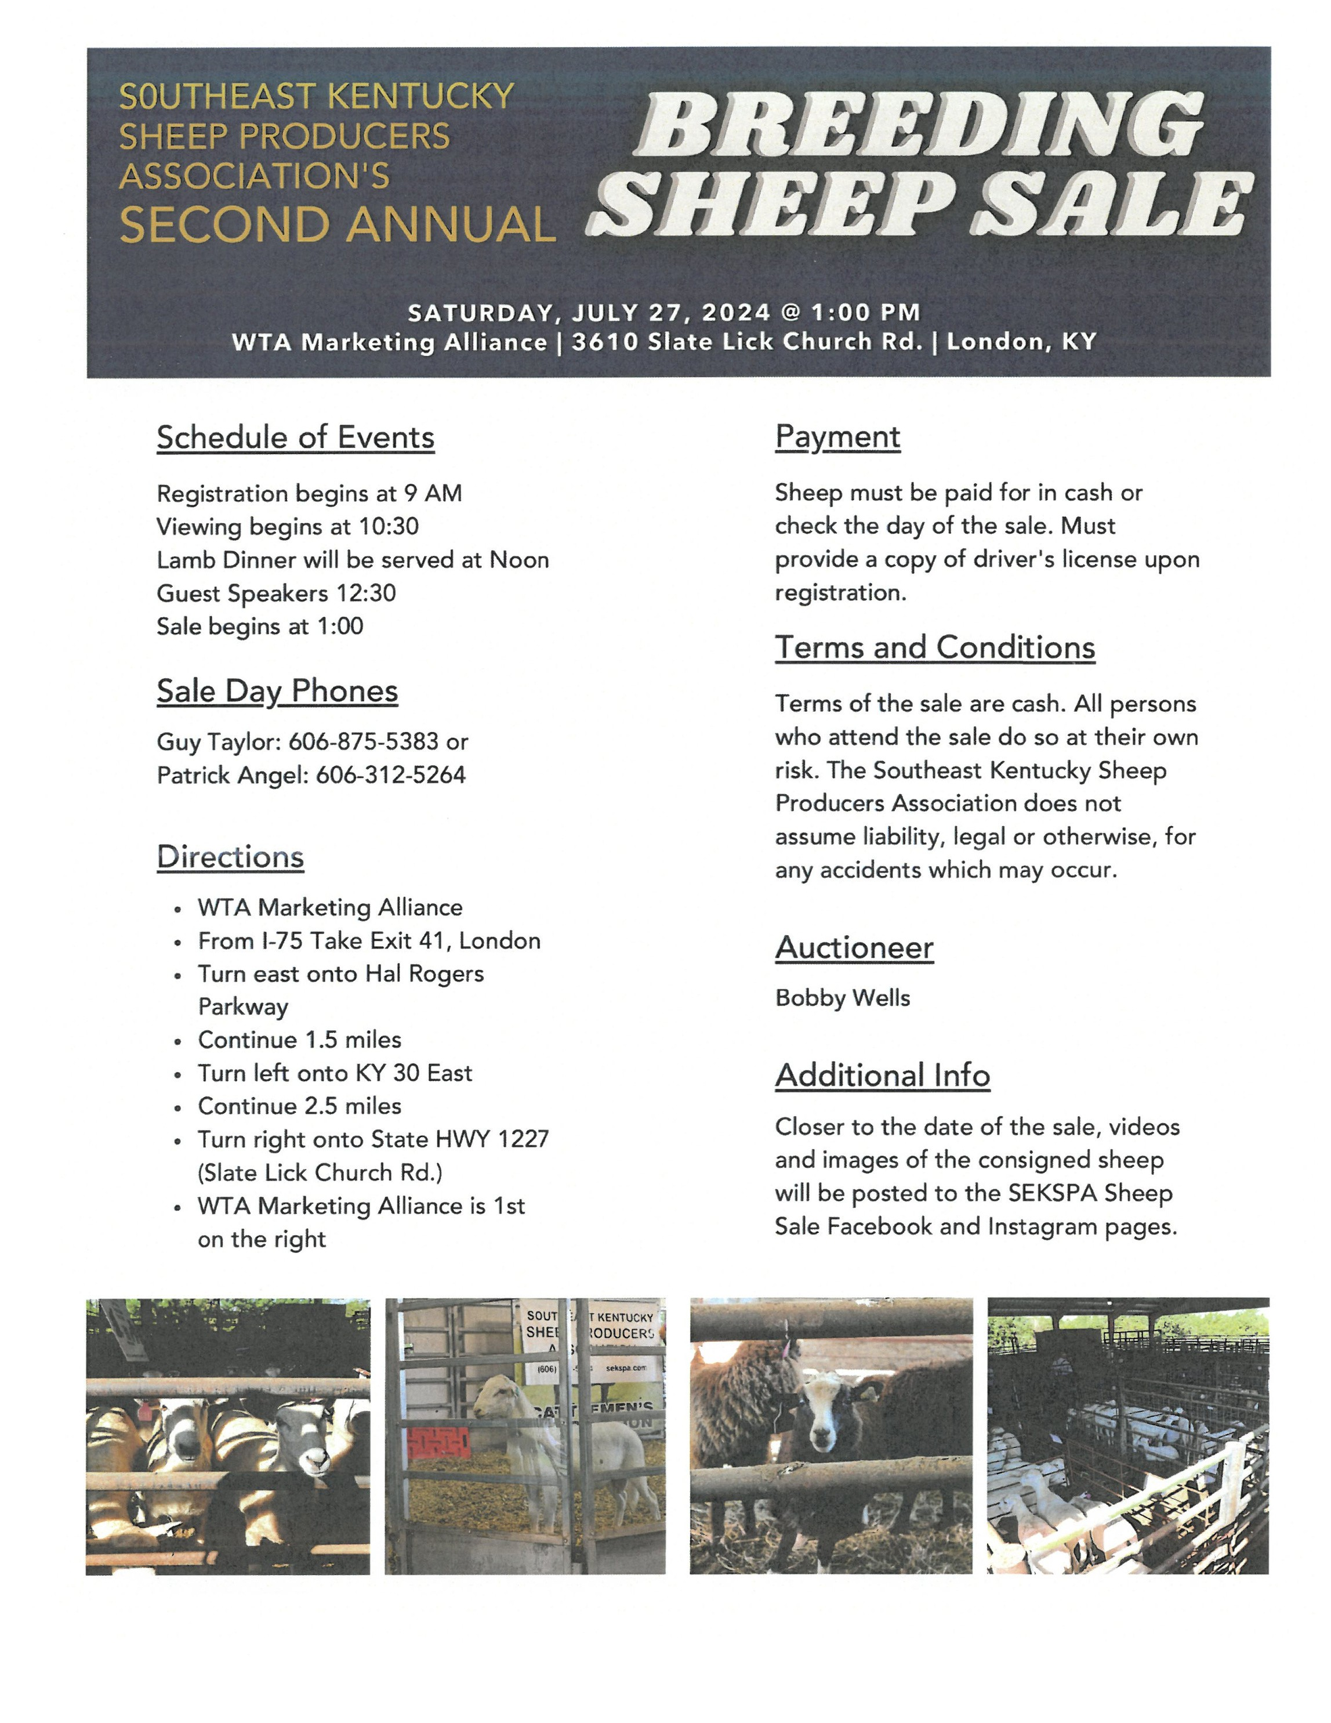
PLEASE CALL TO REGISTER FOR EACH PROGRAM 633-2362 (LIMITED SPACES)

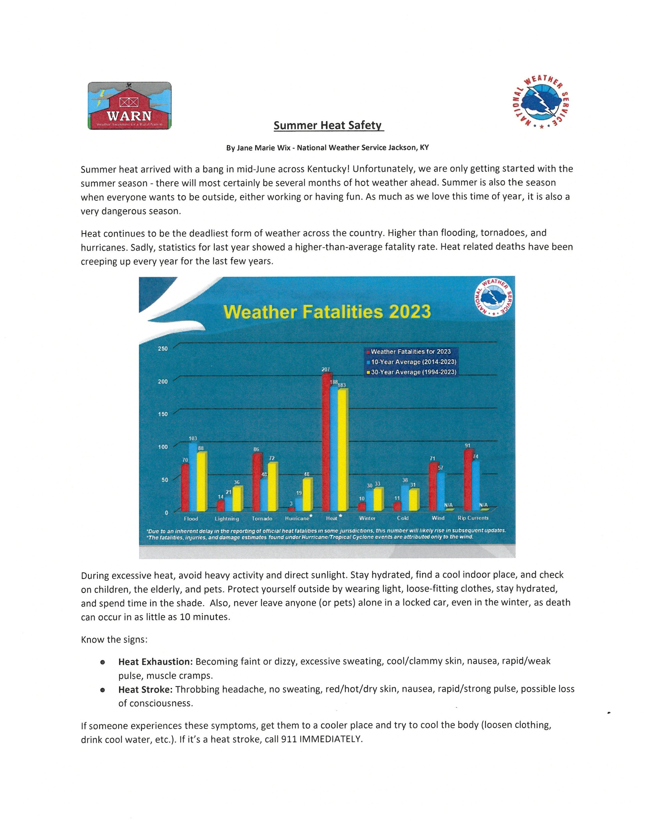
PLEASE CALL TO REGISTER FOR EACH PROGRAM 633-2362 (LIMITED SPACES)

PLEASE CALL TO REGISTER FOR EACH PROGRAM 633-2362 (LIMITED SPACES)

EARLY BLIGHT & SEPTORIA LEAF SPOT OF TOMATO

EARLY BLIGHT AND SEPTORIA LEAF SPOT ARE THE MOST COMMON DISEASES OF TOMATO IN KENTUCKY. TOMATOES PRODUCED IN GREENHOUSES AND HIGH TUNNELS MAY ALSO EXPERIENCE DISEASE. THESE
DISEASES MAY OCCUR INDIVIDUALLY OR TOGETHER. WHILE THESE DISEASES RARELY RESULT IN PLANT DEATH, THE DAMAGE CAUSED TO LEAVES AND FRUIT IMPACTS OVERALL YIELD AND PRODUCE QUALITY. CULTURAL
AND SANITATION PRACTICES CAN HELP REDUCE SEVERITY OF THESE DISEASES, BUT CHEMICAL MANAGEMENT MAY BE NEEDED TO PROTECT PLANTS FROM INFECTION.

EARLY BLIGHT FACTS
SYMPTOMS FIRST APPEAR ON OLDER LEAVES AS SMALL, BROWN LESIONS, WHICH OVER TIME EXPAND AND DEVELOP A CONCENTRIC RING (BULLS-EYE) PATTERN (FIGURE 1). DISEASE SPREADS UPWARD AND LESIONS DEVELOP ON NEWER GROWTH AS DISEASE PROGRESSES. LESIONS MAY MERGE TOGETHER
RESULTING IN A RAPID DIEBACK OF PLANT TISSUE. FRUIT MAY ALSO BECOME INFECTED. AFFECTED FRUIT DEVELOP DARK, BROWN TO BLACK LESIONS WITH CONCENTRIC RING PATTERNS NEAR THE STEM
ATTACHMENT POINT (FIGURE 2).
DISEASE OVERWINTERS IN PLANT DEBRIS LEFT OVER FROM THE PREVIOUS SEASON.
EARLY BLIGHT SPREADS WHEN SPORES ARE CARRIED BY WATER, SUCH AS IRRIGATION AND RAIN SPLASH. WARM, WET CONDITIONS AND PERIODS OF HIGH HUMIDITY FAVOR DISEASE DEVELOPMENT.
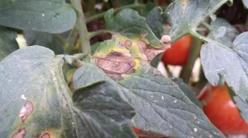
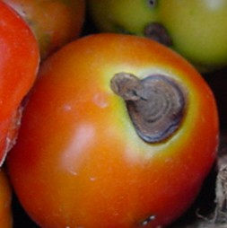
EARLY BLIGHT IS CAUSED BY THE FUNGAL PATHOGEN ALTERNARIA LINARIAE, , WHICH CAN INFECT OTHER SOLANACEOUS HOSTS AND SOME CUCURBITS.

FIGURE 1: EARLY BLIGHT RESULTS IN THE DEVELOPMENT OF BROWN LESIONS WITH A
BULLS-EYE PATTERN. (PHOTO: KIM LEONBERGER, UK)
FRUIT AFFECTED BY EARLY BLIGHT DEVELOP BROWN TO BLACK LESIONS WITH CONCENTRIC RINGS. (PHOTO:
UNIVERSITY OF KENTUCKY VEGETABLE IPM SCOUTING GUIDE TEAM, UK)

PLEASE CALL TO REGISTER FOR EACH PROGRAM 633-2362 (LIMITED SPACES)

SEPTORIA LEAF SPOT FACTS
SYMPTOMS FIRST APPEAR AS SMALL CIRCULAR LESIONS WITH TAN-BROWN CENTERS ON OLDER LEAVES (FIGURE 3) AND LOWER PORTIONS OF STEMS. OVER TIME DISEASE PROGRESSES UP THE PLANT TO NEW GROWTH. AS DISEASE SPREADS, LEAVES MAY BEGIN TO DIE BACK RAPIDLY. HOWEVER, INDIVIDUALLY,
LESIONS CAN STILL BE OBSERVED. DURING PERIODS OF HIGH HUMIDITY, SMALL, BLACK REPRODUCTIVE STRUCTURES MAY BE SEEN IN CENTERS OF SPOTS. SEPTORIA LEAF SPOT DOES NOT AFFECT FRUIT.
DISEASE OVERWINTERS IN PLANT DEBRIS LEFT FROM THE PREVIOUS SEASON. SEPTORIA LEAF SPOT IS SPREAD BY WATER, SUCH AS IRRIGATION AND RAIN.
WARM, WET CONDITIONS AND PERIODS OF HIGH HUMIDITY FAVOR DISEASE DEVELOPMENT.
SEPTORIA LEAF SPOT IS CAUSED BY THE FUNGAL PATHOGEN SEPTORIA LYCOPERSICI, WHICH CAN ALSO INFECT A WIDE RANGE OF SOLANACEOUS HOSTS.

MANAGEMENT
PURCHASE CERTIFIED DISEASE-FREE SEEDS OR TRANSPLANTS
UTILIZE CULTIVARS WITH RESISTANCE OR TOLERANCE TO DISEASES
MANAGE WEEDS IN AND NEAR PLANTINGS, ESPECIALLY NIGHTSHADES AND OTHER SOLANACEOUS WEEDS ROTATE CROPS
INCREASE PLANT SPACING APPLY MULCH LAYER
REMOVE AND DESTROY INFECTED PLANTS OR PLANT PARTS AVOID OVERHEAD WATERING
CLEAN AND SANITIZE TOOLS, POTS, AND EQUIPMENT
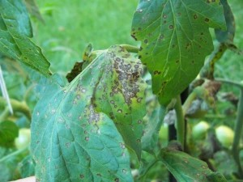
REMOVE AND DESTROY PLANT DEBRIS AT THE END OF THE SEASON

SEPTORIA LEAF SPOT SYMPTOMS INCLUDE THE DEVELOPMENT OF CIRCULAR LESIONS WITH TAN-BROWN CENTERS ON STEMS, PETIOLES, AND LEAVES. (PHOTO: KENNY SEEBOLD, UK)

PLEASE CALL TO REGISTER FOR EACH PROGRAM 633-2362 (LIMITED SPACES)

PHOMOPSIS TWIG BLIGHT & STEM CANKER OF BLUEBERRY

PHOMOPSIS TWIG BLIGHT AND STEM CANKER IS BECOMING MORE COMMON IN KENTUCKY BLUEBERRY. STRESSED PLANTS ARE MORE SUSCEPTIBLE TO THIS DISEASE, AND REPORTS ARE OFTEN ASSOCIATED WITH FIELDS THAT HAVE A HISTORY OF PHYTOPHTHORA ROOT ROT OR SEVERE ABIOTIC DISORDER SUCH AS WINTER INJURY OR HIGH PH.

PHOMOPSIS DISEASE FACTS
SYMPTOMS FIRST APPEAR IN SPRING AS BLIGHTED TWIGS THAT RESULT IN FLOWER BUD LOSS (FIGURE 1).
NECROTIC, REDDISH-BROWN LESIONS MAY DEVELOP AROUND BLIGHTED AREAS AND SPREAD DOWNWARD.
WILTING AND FLAGGING IS OBSERVED AS STEMS DIE (FIGURE 2). GIRDLING CANKERS CAN OFTEN BE OBSERVED LOWER ON STEMS. LEAF SPOTS CAN ALSO OCCUR ON FOLIAGE, AND FRUIT MAY RIPEN PREMATURELY OR ROT. DISEASE IS FAVORED BY WARM, MOIST PERIODS. PLANTS DAMAGED BY FREEZING TEMPERATURES OR STRESSED BY POOR PLANTING SITES ARE MORE SUSCEPTIBLE TO DISEASE.
CAUSED BY THE FUNGUS PHOMOPSIS VACCINII.
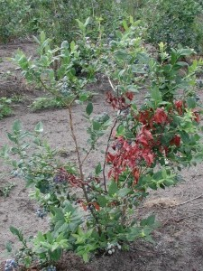
THE PATHOGEN SURVIVES WINTER IN DEAD OR INFECTED TWIGS.
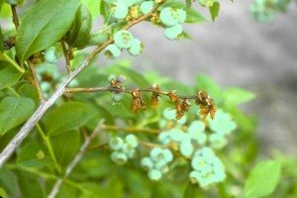

SYMPTOMS FIRST APPEAR AS BLIGHTED TWIGS. (PHOTO: ANNEMIEK SCHILDER, MICHIGAN STATE UNIVERSITY)

INFECTED PLANTS EXHIBIT WILTING AND
FLAGGING AS STEMS DIE. (PHOTO: MARY ANN HANSEN, VPI, BUGWOOD.ORG)

PLEASE CALL TO REGISTER FOR EACH PROGRAM 633-2362 (LIMITED SPACES)

MANAGEMENT OPTIONS

SELECT RESISTANT CULTIVARS SUCH AS ‘BLUETTA’ AND ‘ELLIOTT’
PRUNE OUT INFECTED TWIGS BY CUTTING A MINIMUM OF 6 INCHES BELOW INFECTED TISSUE. DISCARD CUTTINGS; NEVER LEAVE THEM IN THE FIELD.
AVOID PLANTING SITES PRONE TO FROSTS.
MAINTAIN PLANT HEALTH WITH PROPER FERTILIZATION, IRRIGATION, AND WEED MANAGEMENT. AVOID WOUNDING STEMS.
FUNGICIDES MAY BE APPLIED PREVENTATIVELY (BEFORE INFECTION) BEGINNING AT BUD BREAK AND
CONTINUING THROUGH FULL BLOOM FOR PLANTINGS WITH HIGH INFECTION RISK. HOMEOWNERS MAY USE FUNGICIDES THAT CONTAIN THE ACTIVE INGREDIENTS CAPTAN OR PROPICONAZOLE. CONTACT A COUNTY EXTENSION AGENT FOR MORE INFORMATION ON FUNGICIDE USE.
FUNGICIDES DO NOT CURE PHOMOPSIS TIP BLIGHT.

ADDITIONAL INFORMATION

FRUIT, ORCHARD, AND VINEYARD SANITATION (PPFS-GEN-05) BLUEBERRY CANKERS & TWIG BLIGHTS (PPFS-FR-S-10)
MIDWEST BLUEBERRY PRODUCTION GUIDE (ID-210)
DISEASE AND INSECT CONTROL PROGRAMS FOR HOMEGROWN FRUIT IN KENTUCKY (ID-21) BACKYARD BERRY DISEASE, PEST, AND CULTURAL PRACTICES CALENDAR (PPFS-FR-S-25) COMMERCIAL FRUIT PEST MANAGEMENT GUIDE (ID-232)

Shad Baker
Ag & Natural Resources Agent
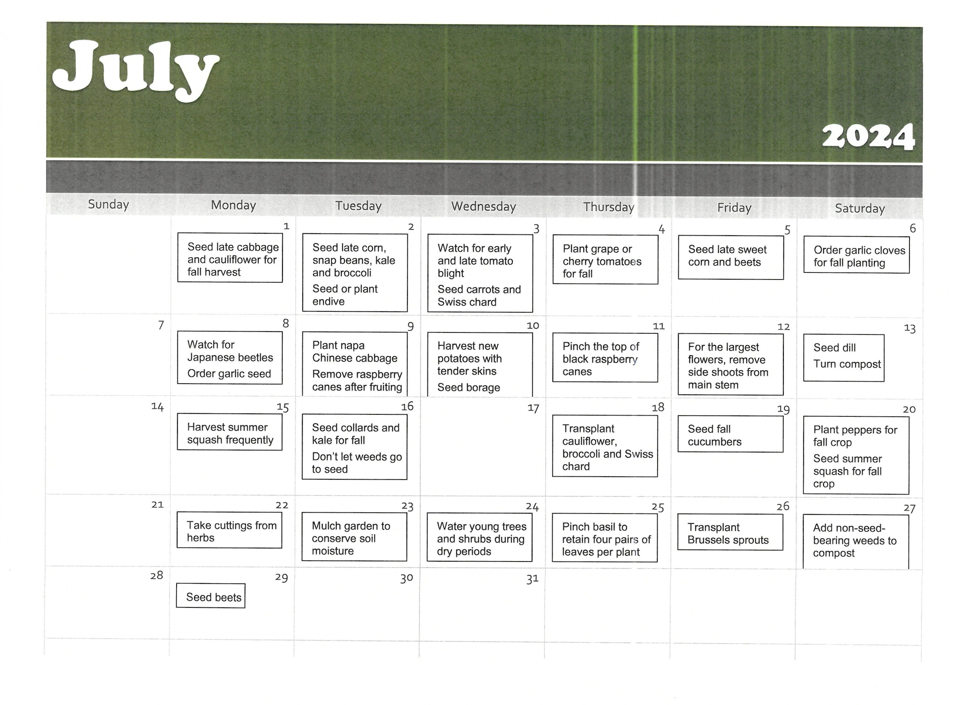






Letcher Homemakers monthly meeting July 9th @ 10:30
Jeremiah Missionary Baptist Church



July 10
1:00 pm

Homemaker Quilt Shop Hop
July 11th @ 8:30



Jenkins Homemaker Monthly Meeting July 12th @ 11:30 Jenkins Library


Traveling the World with Extension July 16th @ 11:30
Come sample Greek Foods, History of Greece and fun activities.

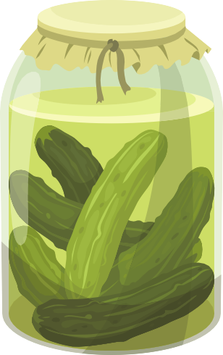
Food Preservation Workshop

July 16th 1:00
Home Canning Pickled and Fermented Foods July 17 @ 10:00



Food Preservation Workshop
Home Canning Vegetables
July 18@10:00

Diabetes Support Group July 25th @ 1:00


Food Preservation Workshop Freezing Basics July 31st @ 10:00


Food Preservation Workshop
Canning Jams, Jellies and Other Soft Spreads August 1 @ 10:00
Homemaker Fundraiser (Scholarships)
White Daisy Boutique August 2

10:00-6 pm



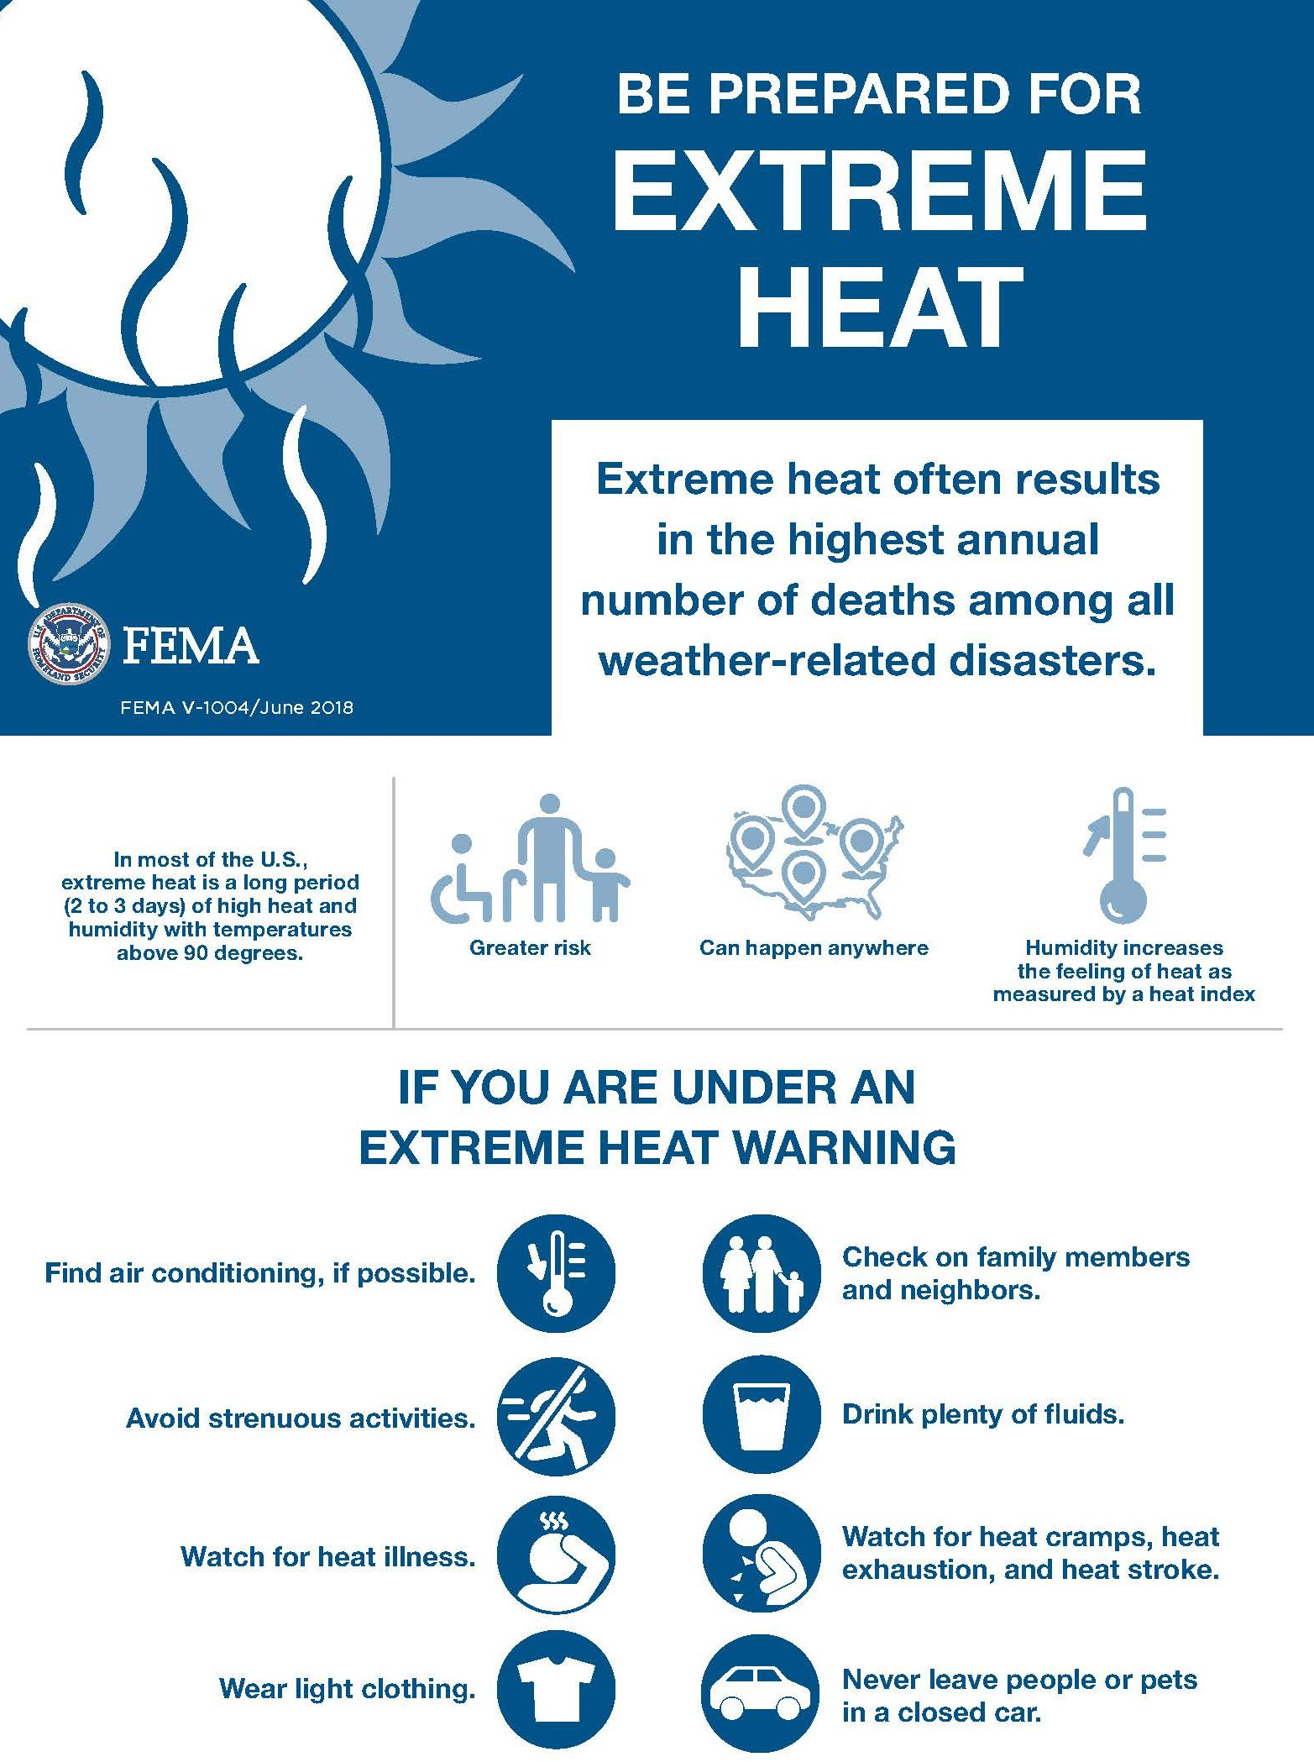

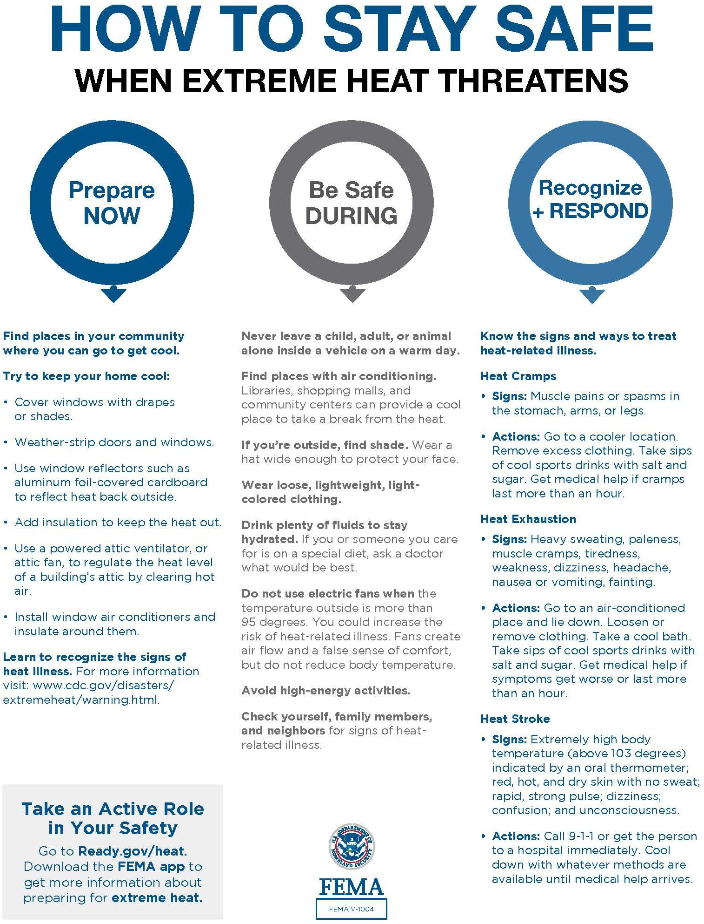

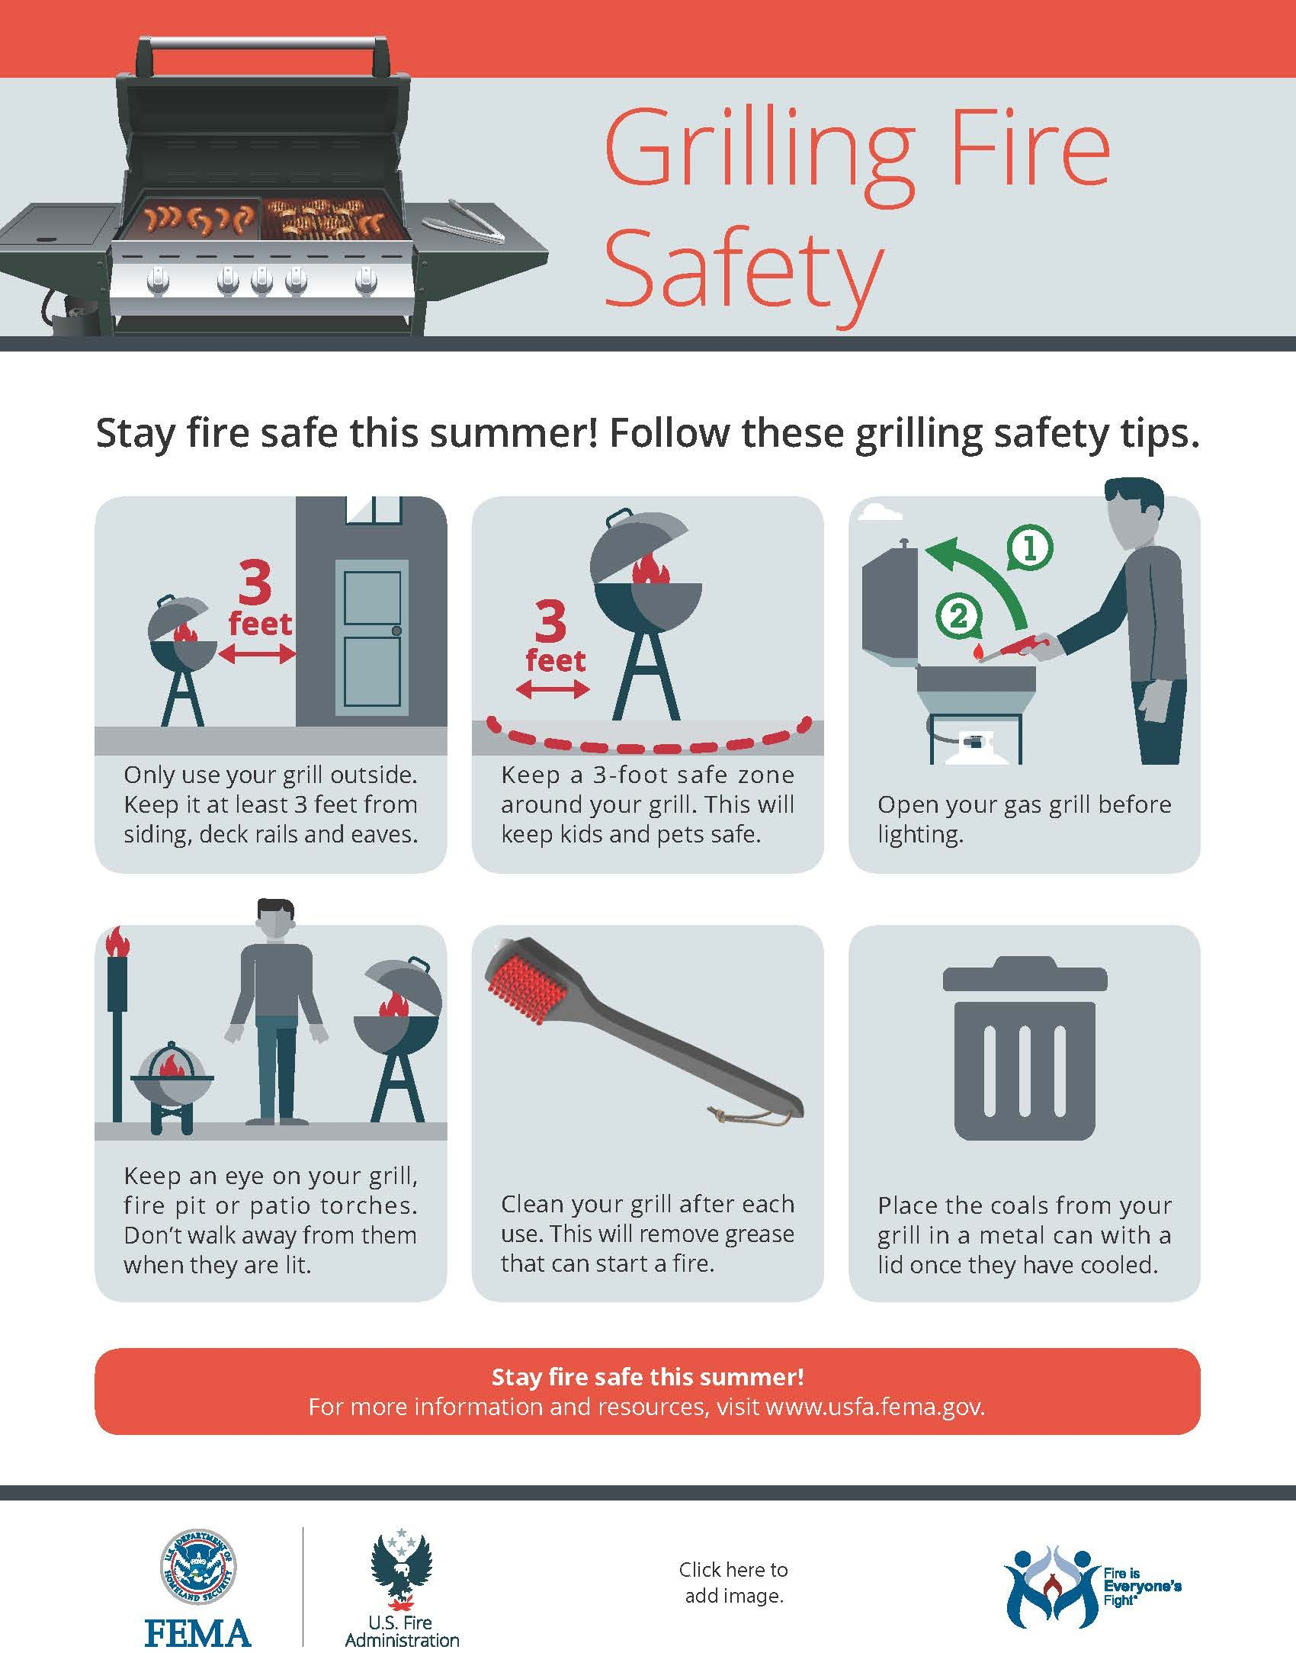

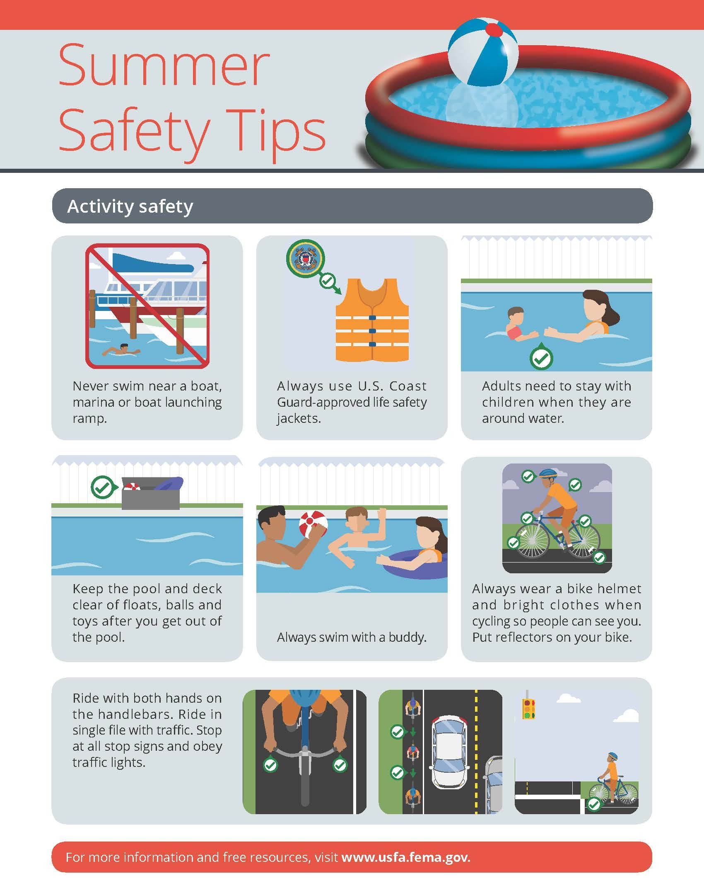





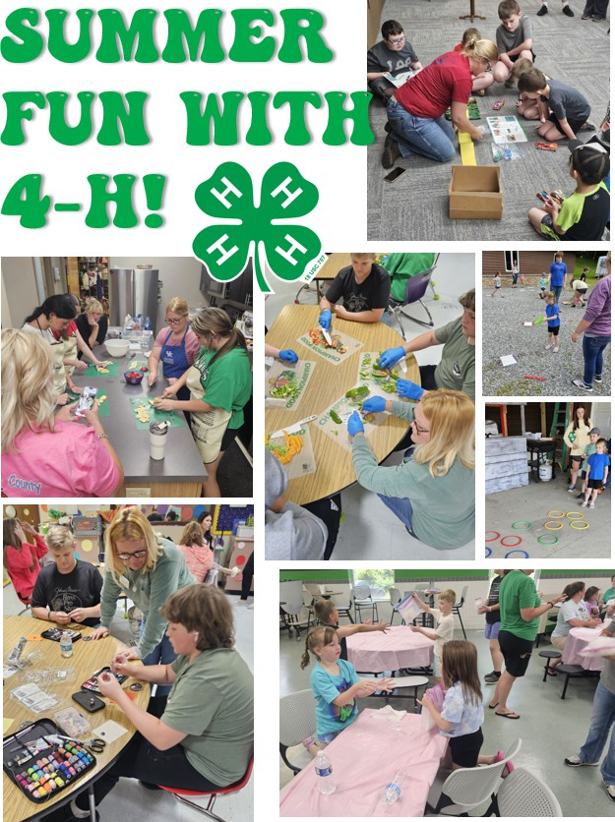







Letcher County Extension 478 Extension Dr
Po Box 784
Whitesburg, Ky 41858 Return Service Requested

